Volunteers # Love in motion.
MCVS graffiti competition

Rules and Regulations :

- This graffiti competition is about volunteers. The graffiti must be about the theme Young people and Volunteering.

- Submissions must be sent to the Malta Council for the Voluntary Sector, Volunteer Centre, 181, Melita Street, Valletta, VLT 1129 till Friday 11th September

- Sketches must be sent in the form of A3 and must be in full colour (final product).No soft copies are too be handed in, only Hard copies. The sketches which will place in the top 10 will be exhibited in the Malta Council for the Voluntary sector, Volunteer Centre.

- The contestants placing first and second will get the chance to paint their sketch on the wall of the Qawra Leap centre.

1st place wall dimensions.
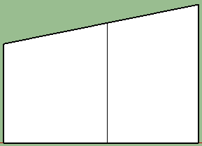
12.0Meters

4.20Meters
3.03Meters
3.65Meters
1ST Prize

2nd place wall dimensions.

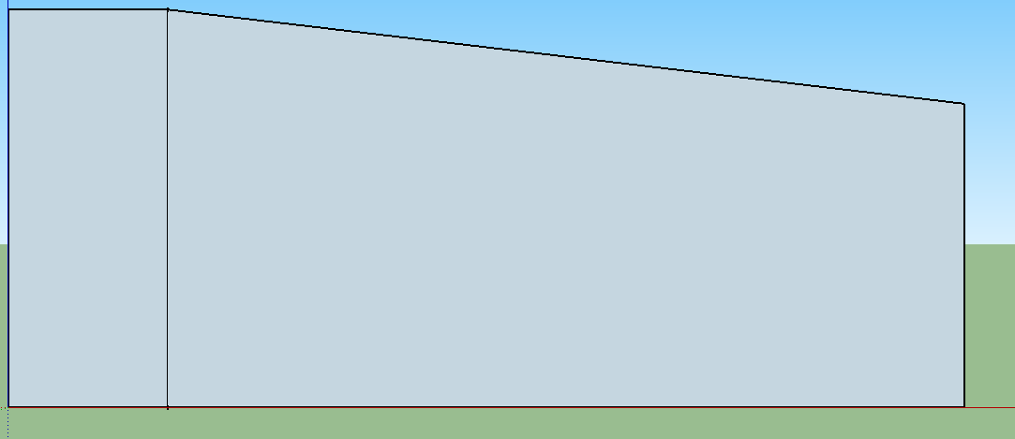
12.00Meters

rs
2.50Meters

rs
1.15Meters

rs
2.00Meters

rs
No Graffiti
On this Wall

2ND Prize

- Apart from painting their sketch, first place will be awarded 500 Euros and second place will be awarded 300 Euros.

- The Malta Council for the Voluntary Sector will pay the costs incurred to paint the graffiti (spray cans etc...).

Application Form:

Name:
Surname:
Address 1:
Address 2:
Locality:
Mobile:
Telephone
ID Card:
Email:

Sketch Names:

Number: | Name
1.
2.
3.

Name: ___________________________

Signature: _________________________

