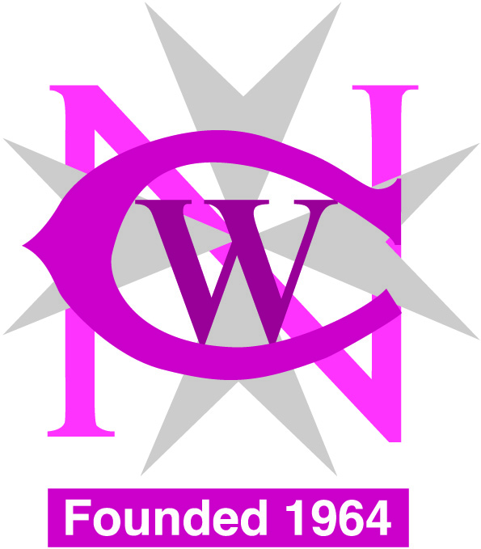
National Council of Women Malta Association for Consumer Rights
ncwmalta@camline.net.mt associationforconsumerrights@gmail.com

Advancing in Society through Empowerment

The Course is open for persons over the age of 18

24 Lectures on: Personal Skills
Assertiveness
Financial Education and Budgeting
Skills audit
Time Management
Health & Safety
IT Awareness
Job Searching

Date: Monday to Thursday starting 9th May 2016 till Thursday 16th June 2016

Time: 9.00am to 12.30pm

Place: National Council of Women Centre
Pope Pius X11 Flats
Mountbatten Street
Blata l-Bajda

For booking kindly contact NCW office on 21248881/21246982
The course is free of charge and it will be in Maltese and English
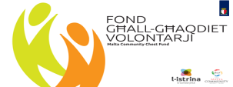
First Call – Social Projects
Projects part-financed by Malta Community Chest Fund
Co-financing rate: 90% MCCF funds. 10% Beneficiary’s funds

