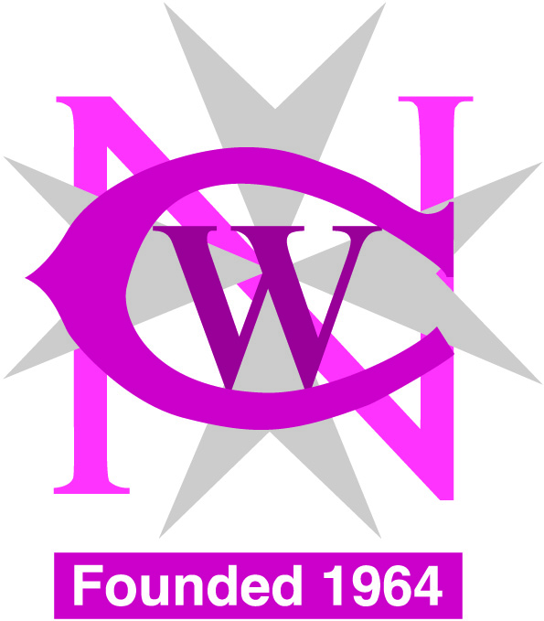
National Council of Women Association for Consumer Rights Malta
ncwmalta@camline.net.mt associationforconsumerrights@gmail.com

Advancing in Society through Empowerment
Course

REGISTRATION FORM Date:____________________

Name : .
ID Number:__________________________________________________
Address: .
.
______________________________________________________________
E-mail: .
Telephone: Mobile:__________________
The Course is held at the NCW centre: 9.00am -12.30pm
Pope Pius Xll Flats, Mountbatten Street, Blata L-Bajda. HMR 1579
Tel- 21248881, 21246982
Malta Community Chest Fund
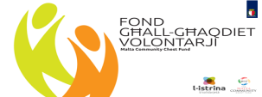
First Call – Social Projects
Projects part-financed by Malta Community Chest Fund
Co-financing rate: 90% MCCF funds. 10% Beneficiary’s funds

