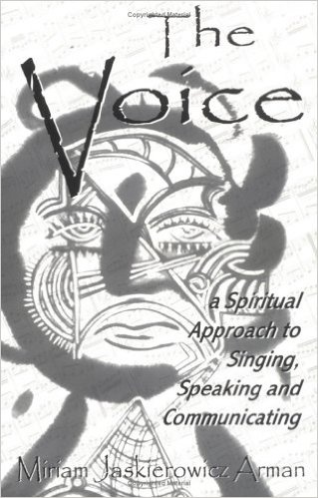
- DO NOT MISS THIS UNIQUE CHANCE TO ATTEND THIS LECTURE BY AN INTERNATIONAL VOICE TRAINER IN AID OF KERALAID TRUST’S WORK IN KERALA INDIA TO HELP AN ORPHANS’ CENTRE RUN BY SALESIANS.
- Wednesday, 27th April 2016
- 7:30 PM
- ROBERT SAMMUT HALL, FLORIANA
- LIMITED AUDIENCE: BOOKING BY ISSUING CHEQUE PAYABLE TO KERALAID TRUST & SEND TO SAVIOUR BUTTIGIEG ‘MIDDLE EARTH’, GHAJN QAJJET, RABAT RBT4013
- 79060926/21455530 or email: saviour.btt@gmail.com.
- A MINIMUM DONATION OF €16 IS BEING REQUESTED.

