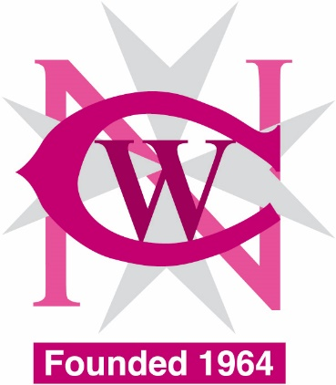

Basic Maltese for Foreigners Course

Would you like to learn Basic Maltese as a foreign language?

The National Council of Women is offering a Basic Maltese for Foreigners Course starting on Friday 19th April 2024 from 6.00pm – 8pm and will be held every Friday evening for 12 sessions of 2 hours each.

Course fee is €50.00 and those students who complete 80% of the course will receive a certificate of attendance plus 80% refund (€40.00)

Payment is required in advance to secure booking and can be made by cash, cheque, bank transfer or Revolut on 7970 9727(please include your name)

Course will be held at NCW Learning Centre, Pope Pius XII Flats 3/4, Mountbatten Street, Blata l- Bajda.

For Booking and further information kindly email: ncwmalta@camline.net.mt or phone NCW office on 21246982 / 21248881 from Monday to Friday 8.30am - 12.30pm

